### Experiment – No-7

### *Problem Statement :* City Coloring problem: The problem is Constraint Satisfaction Problem. The problem is to color each city using only three colors but no adjacent cities can be colored the same. The problem might seem so easy but it’s really challenging how to tell this to a machine. But using prolog logic it is kind of easier because all you have to do is to specify the rules of the problem and prolog will answer.

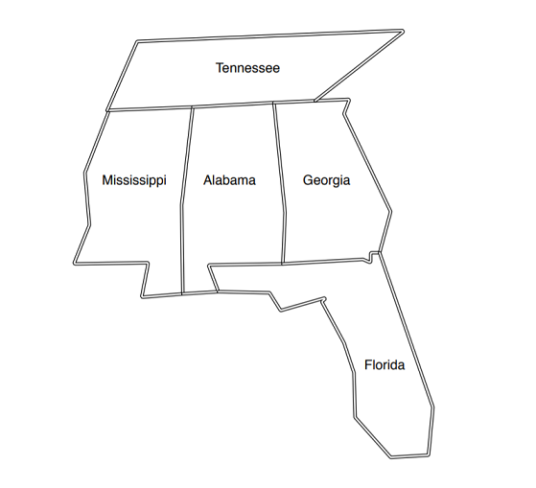

***Program:***

pip install pytholog

import pytholog as pl

city_color = pl.KnowledgeBase("city_color")

city_color([

    "different(red, green)",

    "different(red, blue)",

    "different(green, red)",

    "different(green, blue)",

    "different(blue, red)",

    "different(blue, green)",

    "coloring(A, M, G, T, F) :- different(M, T),different(M, A),different(A, T),different(A, M),different(A, G),different(A, F),different(G, F),different(G, T)"

])

print(city_color.query(pl.Expr("coloring(Alabama, Mississippi, Georgia, Tennessee, Florida)"), cut = True))

### *Output :*

